# Lab: Introduction to Java EE

# West Compass Dealer Shop

West Compass Dealer Shop is an application in which you register cars, with several properties.

You will have to create a simple multi-Servlet application which has several pages and 1 object entity.

## Data

This is the data layer of the application. There is 1 data object for you to implement.

### Car

Create a Car class, which holds the following properties:

* model – a **String**.
* **brand** – a **String**.
* year – an **Integer**.
* engine – a **String**.

## Home Servlet

Implement a **Servlet**, which listens on the **index route** (“/”).

It should support only a **GET** request.

It should return the following HTML page, upon a **GET** request.



## Car Create Servlet

Implement a **Servlet**, which listens on **route** (“/create”).

It should support **GET** & **POST** requests.

It should return the following HTML page, upon a **GET** request.

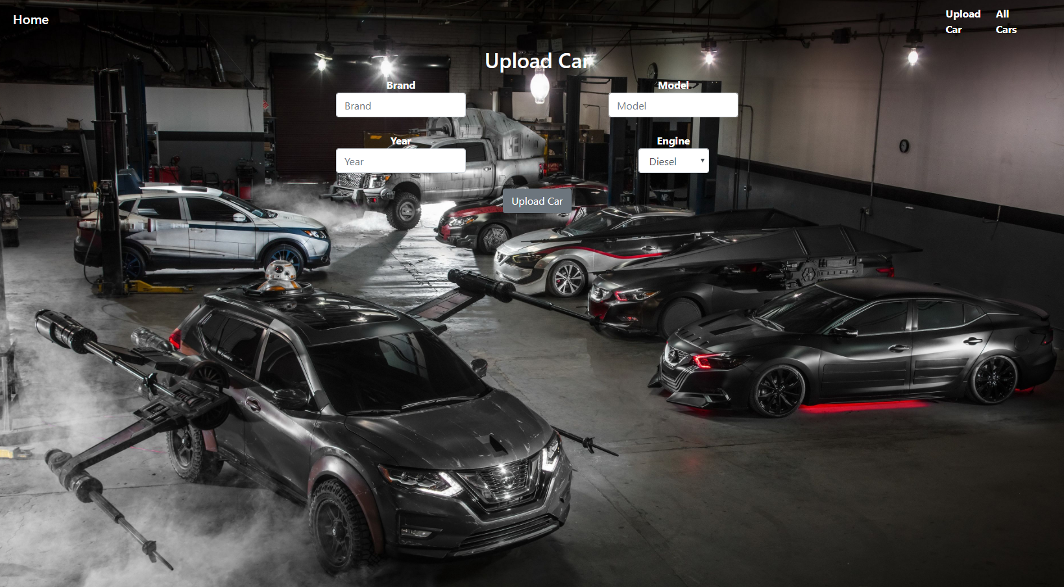

## All Cars Servlet

Implement a **Servlet**, which listens on **route** (“/all”).

It should support only a **GET** request.

It should return the following HTML page, upon a **GET** request.

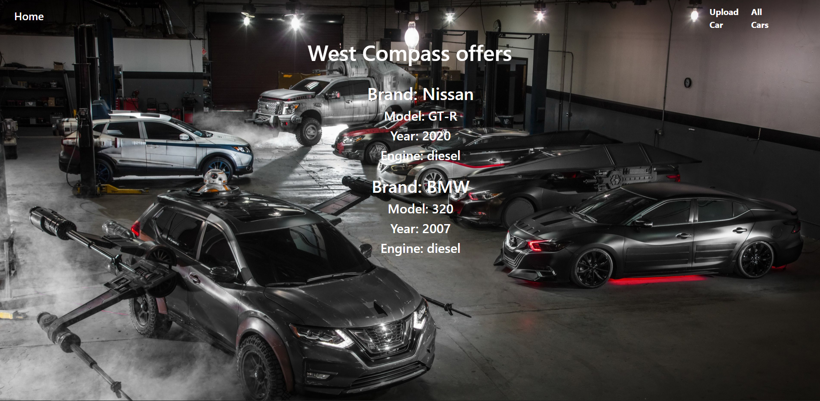

Each car needs to be shown in the format below.

